1. Provide a screenshot of your Terminal window to show that you successfully started Redis.



1. Provide a screenshot of your Terminal window to show that you successfully started NiFi.

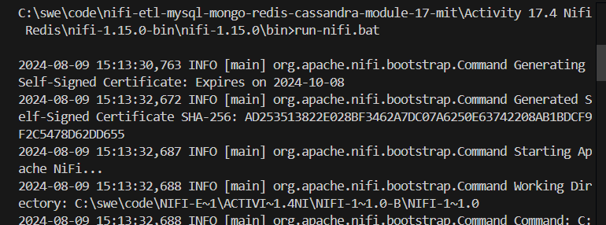

1. Provide a screenshot to show that you successfully opened the NiFi UI.

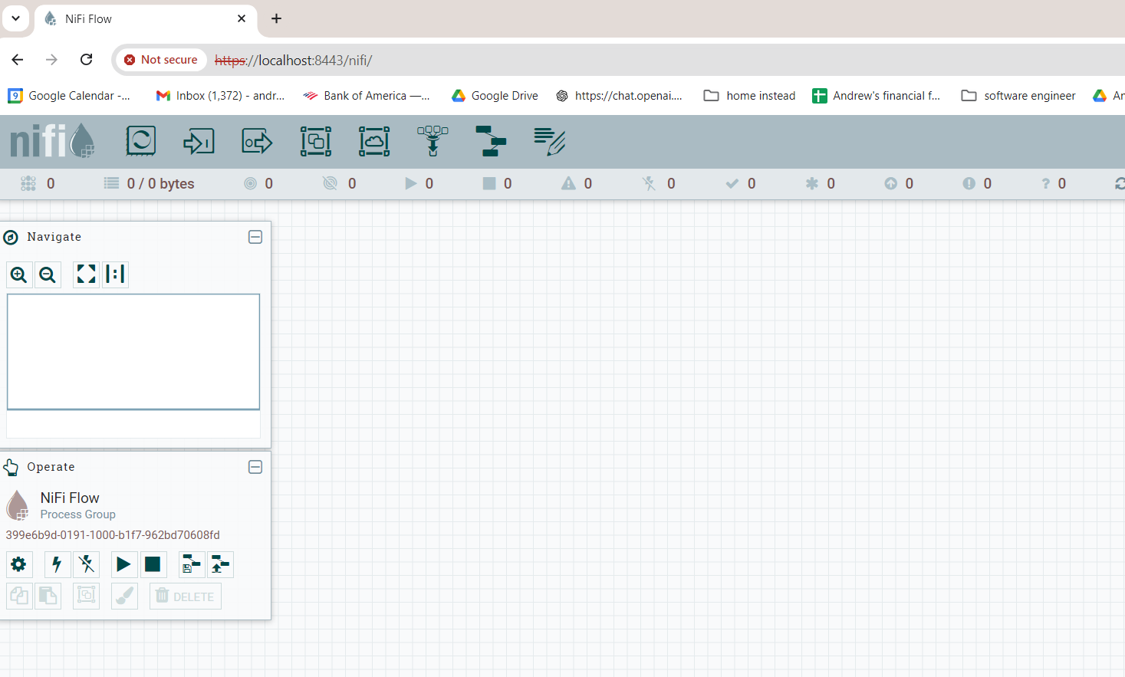

1. Provide a screenshot to show that you set the RedisConnectionPoolService *controller* settings correctly.

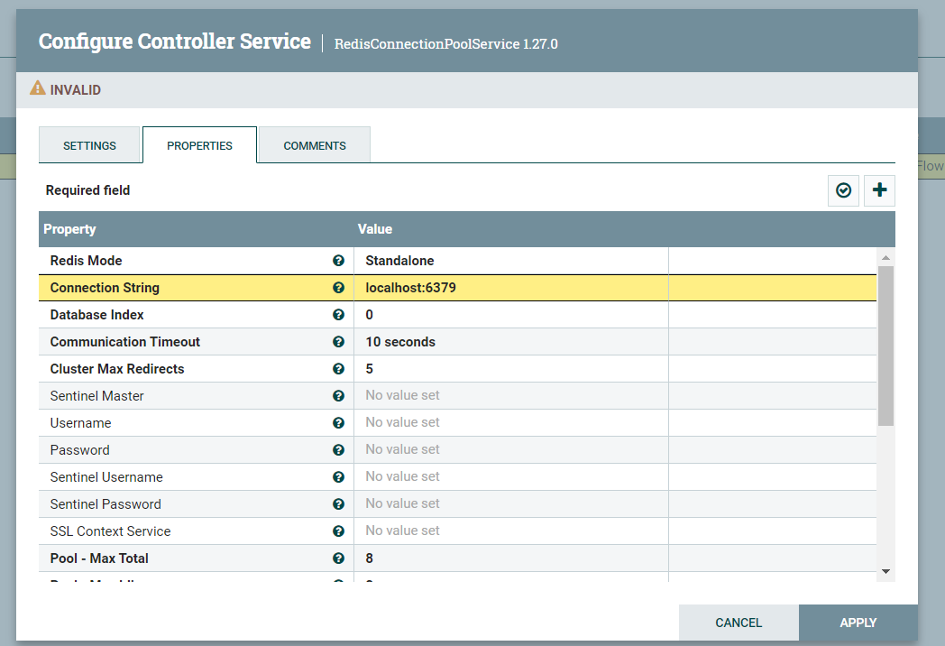

1. Provide a screenshot to show that you set the RedisDistributedMapCacheClientService *controller* settings correctly.

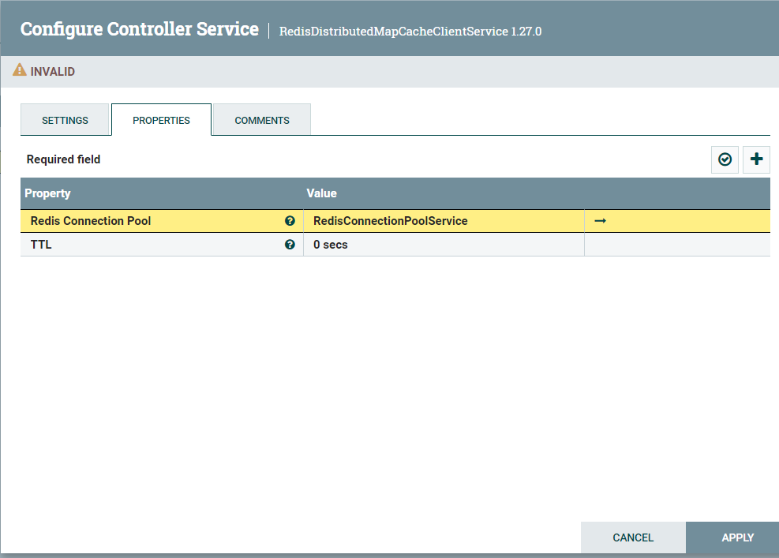

1. Provide a screenshot to show that you enabled both the RedisConnectionPoolService and RedisDistributedMapCacheClientService *controllers.*

*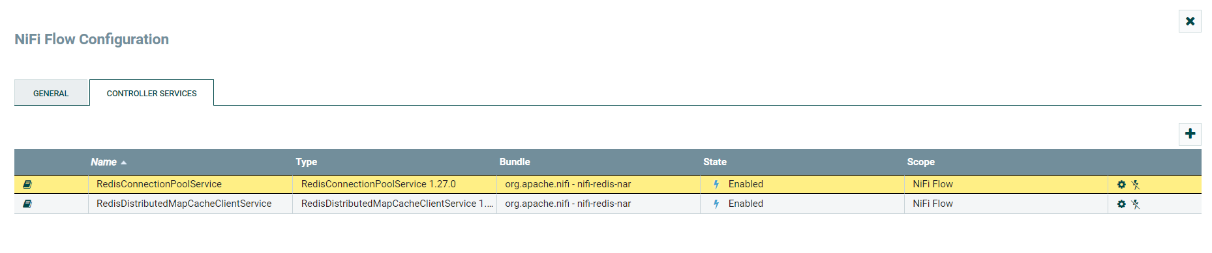*

1. Provide two screenshots. The first screenshot should show that you set the values in the PROPERTIES tab correctly. The second screenshot should show that you updated the scheduling time in the SCHEDULING tab correctly.

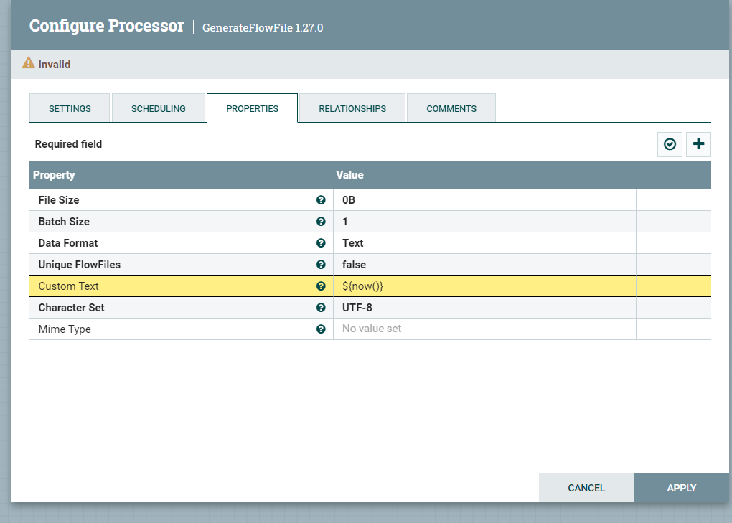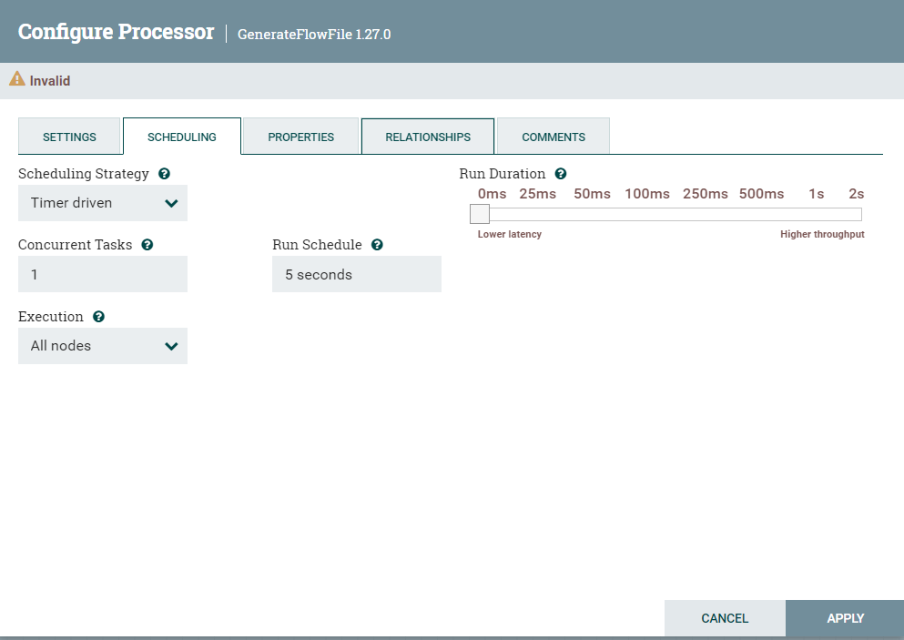

1. Provide a screenshot to show that you set the PutDistributedMapCache *controller* settings correctly.

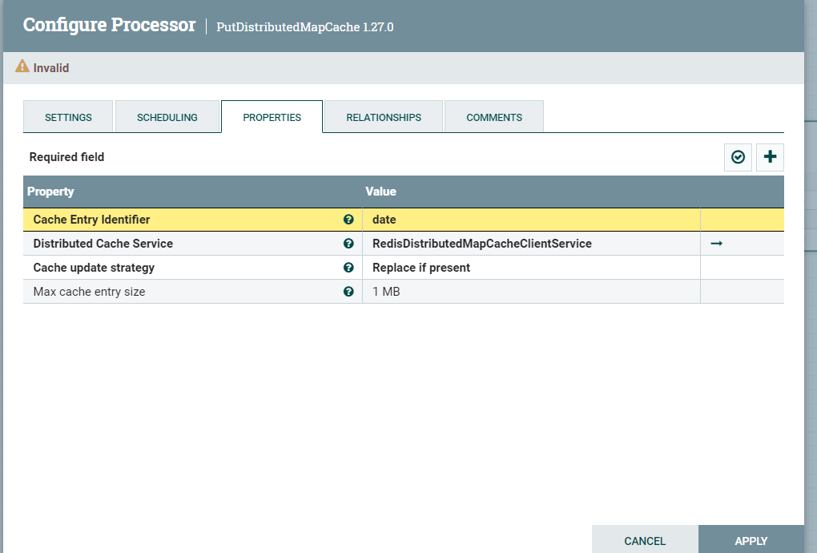

1. Provide a screenshot to show that you set the FetchDistributedMapCache *controller* settings correctly.

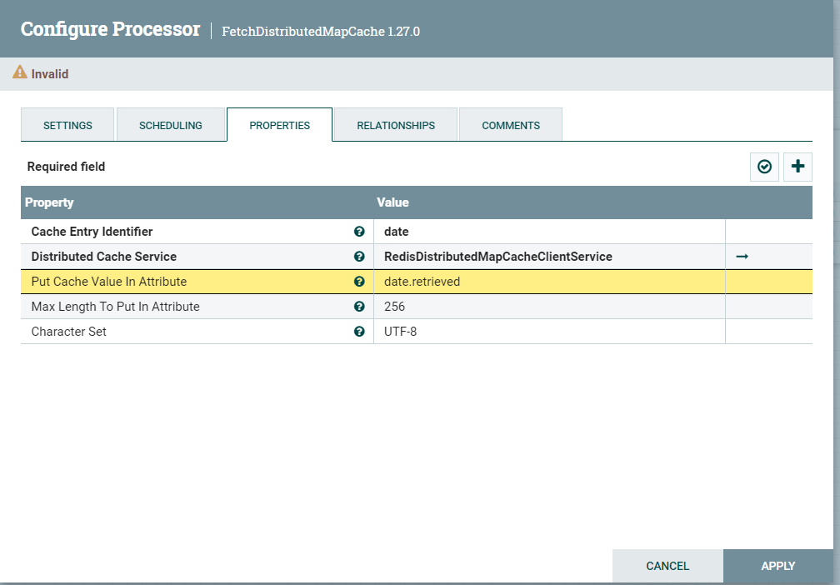

1. Provide a screenshot to show that you have all the *processors*, GenerateFlowFile*,* PutDistributedMapCache, FetchDistributedMapCache, and LogAttribute,ready in NiFi.

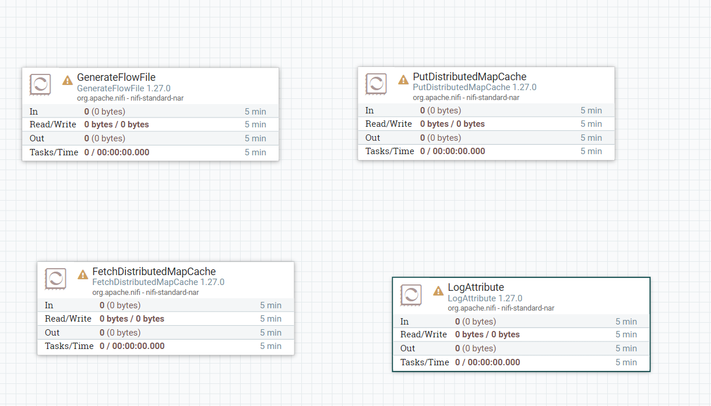

1. Provide a screenshot to show that your *flow* is running with the correct relationships.

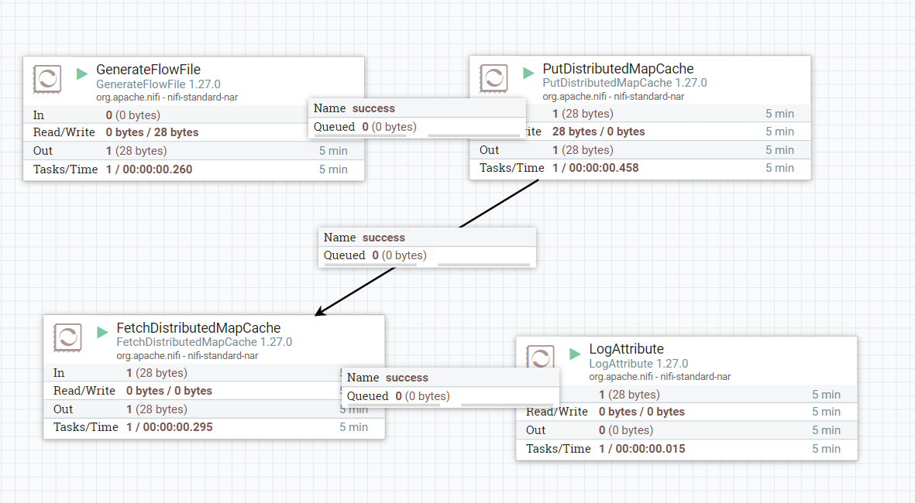

1. Provide a screenshot to show that the nifi-app.log is being populated with the current date and time.

